Mathematics


https://www.mathsisfun.com/fractions_division.html
Because dividing is the opposite of multiplying! We need to rotate
the fractions being divided.
"Dividing fractions, as easy as pie,
Flip the second fraction, then multiply.
And don't forget to simplify,
Before it's time to say goodbye"
Step 1. Turn the second fraction (the one you want to divide by) upside down
(this is now a reciprocal).
Step 2. Multiply the first fraction by that reciprocal
Step 3. Simplify the fraction (if needed)
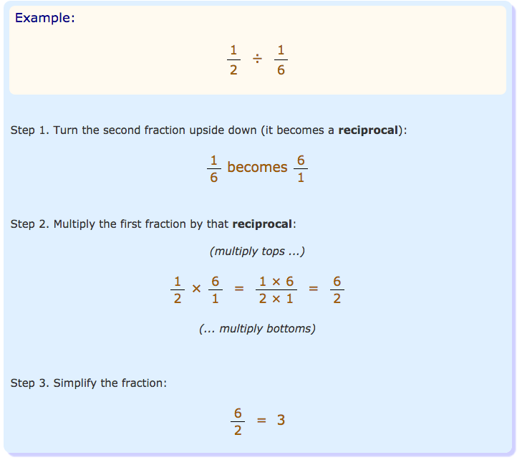

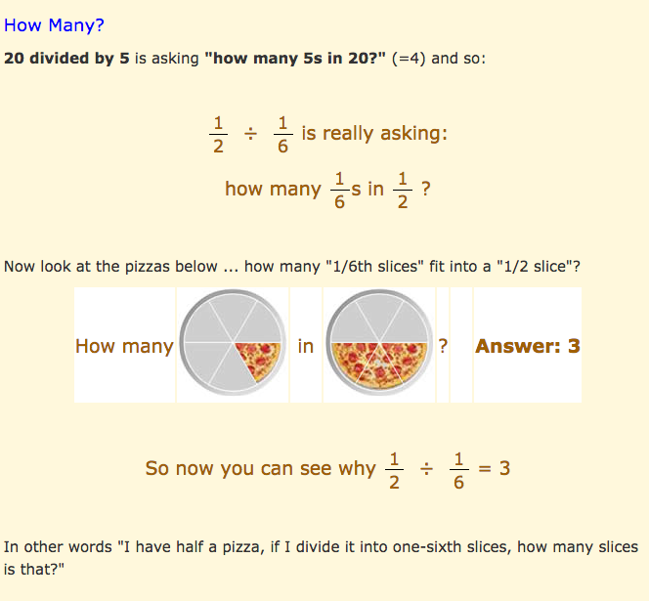

Fractions and Whole Numbers
What about division with fractions and whole numbers?
Make the whole number a fraction, by putting it over 1.
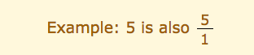

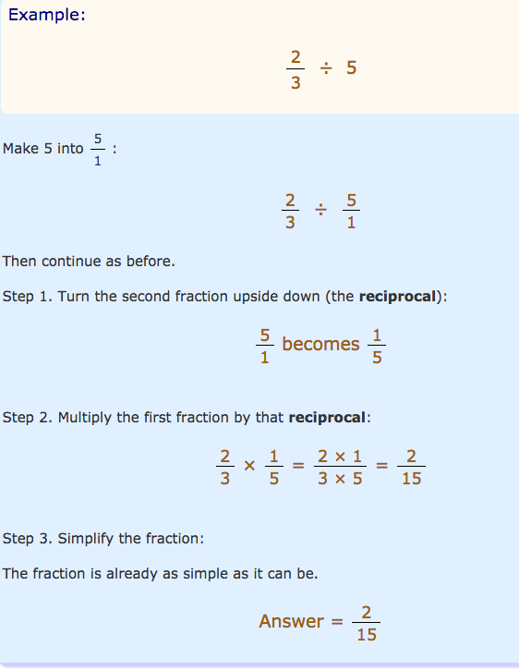

To Divide a Fraction by a Whole Number:
- Step 1. Multiply the bottom number of the fraction by the whole number
- Step 2. Simplify the fraction (if needed)
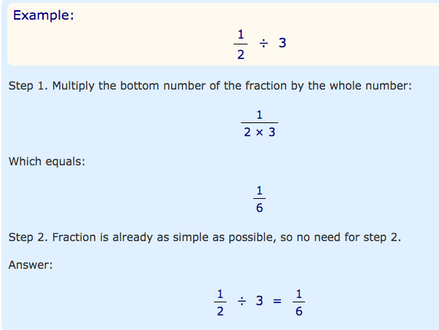


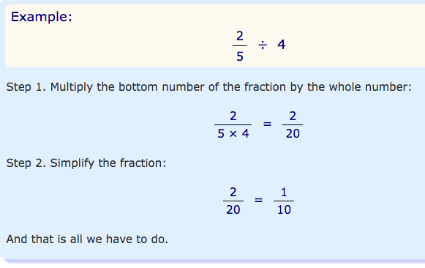
Need help just ask

